ACTION PORTY

Minute of Annual General Meeting held on Monday, 31 May, 2021 on Zoom

1. INTRODUCTION
Justin Kenrick (Chair) welcomed everyone to Action Porty’s 2021 Annual General Meeting which because of the circumstances was taking place on zoom. He confirmed that between those present and proxy votes submitted in advance of the meeting, the AGM was quorate (list of attendees, apologies and proxy votes attached as an appendix). Justin also explained that the agenda, minute of previous meeting and accounts had all been posted on web-site, along with notice of the AGM and the proposed motion on boundaries.

2. MINUTE OF THE PREVIOUS AGM
The minute of last year’s Action Porty AGM, held on 27 February, 2020 was agreed as a correct record of the meeting. Moved Cathy Maclean and seconded Gus Macdonald. There were no matters arising from the minute.

3. 2020/21 ACTIVITY
Ian Cooke provided an overview of what Action Porty had been doing since the last AGM. The previous 12 months had been dominated by the Coronavirus pandemic, with Bellfield being closed for the best part of that period. However, Bellfield is now in the process of re-opening in a phased and safe way. Ian outlined the additional measures which had been put in place.
Ian explained the range of work undertaken by the Board over the last 15 months. The solar panels are up and running; a 2 battery energy storage system has been installed; the large hall toilets have been refurbished; the floors of both halls have been sanded and varnished, the Celebration Hall roof space has been insulated; and the Bellfield web-site upgraded. Despite the closure of Bellfield Action Porty had organised a Bellfield Xmas tree, the Winter Wanderland project and the Absent Friends event.
Ian also touched on the evolving plans for a major capital refurbishment of Bellfield, which is likely to involve Action Porty running a community share issue. In response to a question from Alastair Cameron, Ian confirmed that there would be an opportunity for members to comment on the development plans.

4. FINANCIAL REPORT
Jennifer Elliot, treasurer, ran through a presentation on the financial position of Bellfield. She talked to the accounts for 2019/20 which had been independently inspected by accountants, Wylie Bisset. Despite Bellfield having to close in March 2020, the accounts for the year evidenced a strong trading position, which had been achieved without any revenue grant support. This set of accounts had been considered and agreed by the Board of Trustees.
Jennifer then explained the position for the 2020/21 financial year, during which time Bellfield had mostly been closed to the public. She welcomed the financial support from the furlough scheme and other ‘recovery’ grants, which had helped keep Action Porty afloat during a period of very limited income. Jennifer also explained the importance of our reserves during this challenging period. She also acknowledged the various grants received which had funded a range of repairs, improvement works and projects.
Finally, Jennifer explained to the AGM that a budget had been set for 2021/2 which illustrated how Action Porty will emerge from the Coronavirus pandemic. This included contracting a bookkeeper to support the financial work requited and the imminent appointment of a new part-time administrator. Jennifer conclude her report by thanking Morag Donaldson for her sterling work in fielding all the booking enquiries during the last number of months.
In response to this presentation there were a couple of questions from the floor which Jennifer responded to.

5. BOARD OF DIRECTORS / TRUSTEES
The Chair explained that 3 trustees – Shauna Macdonald, Ben McLeish and Fi Crosbie had stepped down from the board during the course of the year. He thanked them all for their contribution to the work of Action Porty. The remaining 8 trustees – Justin Kenrick, Ian Cooke, Kyrsta Macdonald-Scott, Jennifer Elliot, Alan Simpson, Cathy Maclean, Al Reid and Morag Donaldson – had all indicated a willingness to serve for a further year. As 3 trustees had stepped down, there was no need for any further members to stand down and face re-election.
Justin also explained that Nadira Tucker, who had been volunteering with Action Porty for a number of months, was interested in joining the Board, and that her nomination was supported by the Board of Action Porty. The current 8 trustees, with the addition of Nadira, means that Action Porty has 9 board members for the forthcoming year. Justin flagged up than anyone else interested in joining the board, or simply finding out more about what’s involved, should get in touch.

6. PLANS FOR 2021/22
Justin Kenrick flagged that in addition to the ongoing work around Bellfield and related projects, Action Porty is also actively exploring taking on a wider role within the community. He explained that in order to do this, there was no requirement to amend our articles. The context for this was discussions with other organisations in Portobello, who recognised the need for a strategic community anchor organisation in Portobello. While this does not have to be Action Porty, we were actively encouraged to consider taking on this role. Justin also explained plans to host a community consultation over the next few months and the outcomes of this would provide ‘an agenda’ for the community, and direct any development trust.
Justin also stressed that in taking on a wider role, it was important that this doesn’t take energy away from Bellfield but rather helps enable Bellfield to flourish. To this end, it is proposed that Action Porty would establish an additional ‘board’ that was specifically focused on managing and developing Bellfield. Justin flagged up that a future meeting would be called on this issue in the weeks ahead.

7. MOTION – BOUNDARY EXTENSION
Within this context of Action Porty taking on a wider role, the Chair then proposed that we extend the boundaries of the organisation to take in Seafield – the area shaded in the map high (see appendix 1). This would strengthen the ability of Action Porty to represent the aspirations of the community within any regeneration or development processes on the Seafield site. Justin pointed out that this proposal was supported by the 4 Community Councils which form the Seafield Connecting Coastal Communities group, and in particular Craigentinny Community Council within whose boundaries, the Seafield site currently sits. Following a couple of questions of clarification, this motion was overwhelmingly carried by the AGM.

8. CLOSE OF MEETING
There being no other business, the Chair thanked everyone for their attendance and support, and closed the formal part of the meeting.

Appendix 1: Boundary Map
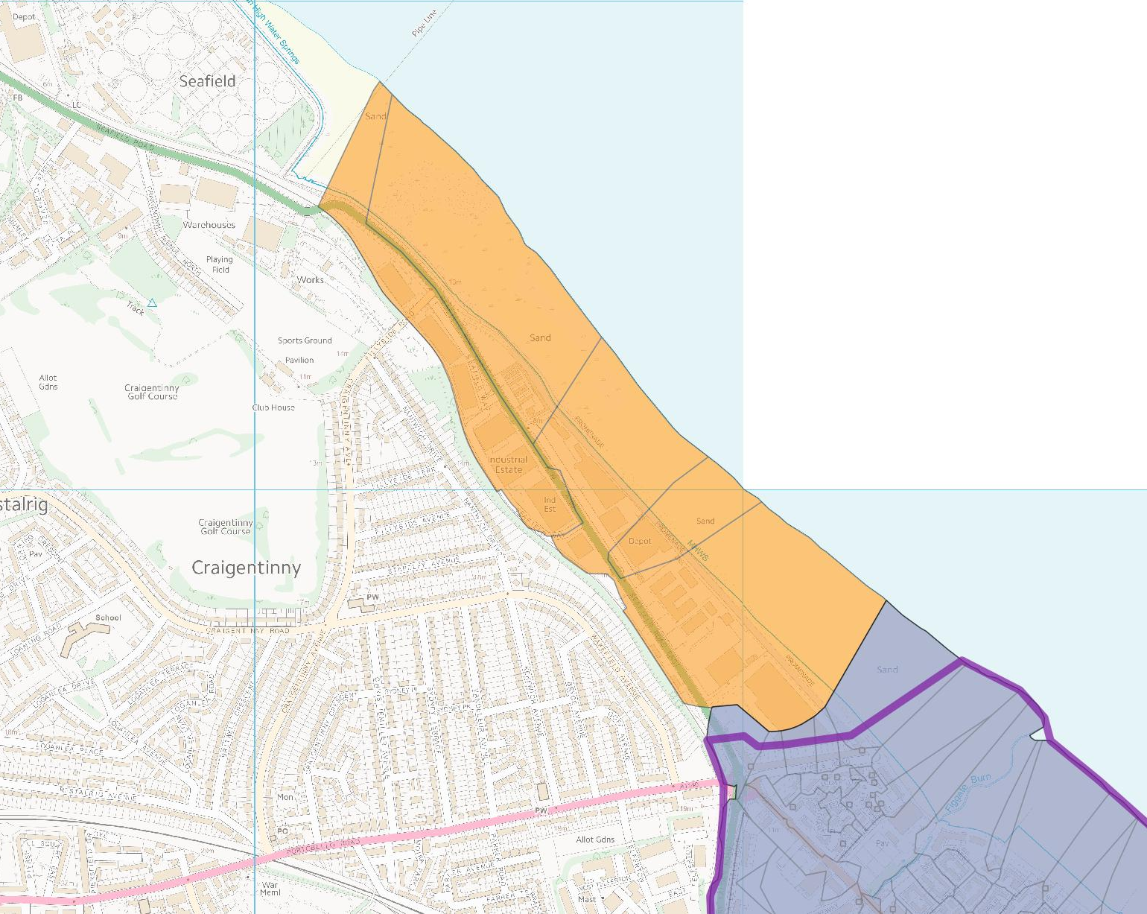

Appendix 2: Attendance
PRESENT (ordinary members)
Justin Kenrick | Alan Simpson | Jennifer Elliot | Morag Donaldson
Ian Cooke | Al Reid | Cathy Maclean | Kyrsta Macdonald-Scott
Nadira Tucker | Margaret Munro | Alastair Cameron | Gus Macdonald
David Calder | David Cooper | Allan Brown | Anne Mart Bergseng
Anne Byrne | Damian Harney | Yvoner Vance | Tommy Black
Thea McMillan | Heather Stacey | Jane Chisolm | Heather Macdonald
Mike Tucker | Rona Gray | Kirsty Carver | Josephine Petersson
Lee Kindness | Stephen Hawkins | Lynn Darke | Matthew Gilbert-Straw
Barbara Middleton

PRESENT (Associate Members and others)
Frazer McNaughton | Lynn Houmdi | Gordon McCulloch | Jo Jeffrey
Geoff Pearson | Joan Robertson | Sarah Jane Summers | Mary Thomson

APOLOGIES (and proxy votes)
Eva Schonveld | Oli Furness | Mary-Jane Elton | Ian Schofield
Ian Newton | Colin Cuthbert | James Lewis | Jane Lewis
Penny Johnstone | Saul Kenrick | Blue Kenrick | Mikey Davidson

